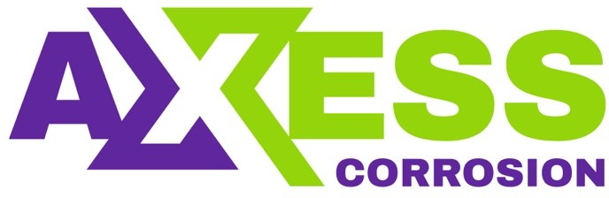

Daily Progress Report

Installation / Location | PS-3
Subject | Corrosion Monitoring Activities
Contract Number | LC241047A0
Assigned Axess Representatives | Stuart Dunthorne
Date of Issue | 13-07-2025

Activities Summary
Work activities continued today, with corrosion coupons being installed at 1 new location, and coupons retrieved & replaced at 1 other location. A new ER Probe was also installed at a new location and setup with a new ID on the Checkmate handheld unit. A further 6 locations had external servicing performed.

Time | Activities
06:00 to 07:00 | Awaiting gas test & permit issue
07:00 to 11:30 | Install new coupons & holder at 1 location and a new ER Probe at 1 location
11:30 to 12:30 | Lunch
12:30 to 16:30 | Continuing coupon retrievals at 1 location and ER Probe external servicing
16:30 to 18:00 | Reporting

Locations Serviced Summary
Tag No | Line Description | Work Completed
53-XCC-1400 | 10-OC-530263-15151  10” Oil Line | Removed Solid Plug. Install new 2.5” Strip Coupon Holder and 3” Strip Coupons. Access Fitting is new (old one was corroded)
53-XCP-1401 | 10-OC-530263-15151  10” Oil Line | Removed Solid Plug. Install new 8.75” S8 Flush ER Probe & obtain reading. Access Fitting is new (old one was corroded)
53-XCC-1143 | 8-OC-530214-15101  8” Oil Line | Removed & Replaced 3” Strip Coupons. Replaced all pressure retaining seals.
53-XCP-1144 | 8-OC-530214-15101  8” Oil Line | Cap removed, fitting threads brushed and re-greased
53-XCC-1402 | 12-OC-530264-15101  12” Oil Bulk Oil Line from BH-D07B WHJ to PS3-C Manifold | Cap removed, fitting threads brushed and re-greased. Photos obtained of corroded sealing face
53-XCP-1403 | 12-OC-530264-15101  12” Oil Bulk Oil Line from BH-D07B WHJ to PS3-C Manifold | Cap removed, fitting threads brushed and re-greased
53-XCC-924 | 10-OC-530016-15151  10” Oil from BH-40-01 WHJ to PS3-C Manifold | Cap removed, fitting threads brushed and re-greased. Measurements obtained to confirm no access for tool
53-XCC-1142 | 10-OC-530213-15151  10” Line D/S 53XZV-1272 | Cap removed, fitting threads brushed and re-greased. Measurements obtained to confirm no access for tool
53-XCP-1137 | 10-OC-530213-15151  10” Line D/S 53XZV-1272 | Cleaned externally only. Previously reported pressure leaking so cap not removed. Measurements obtained to confirm no access for tool

Tag No | Line No / Description | Pressure  (psi) | A/F Orientation | Scope of Work | Retrieved Coupons ID /  Holder Length | Coupon Appearance | Installed Coupons ID / Weight / Material / Date | Tool Used | Location Access | Remedial Actions
53-XCC-1400 | 10-OC-530263-15151  10” Oil Line | 1500 | 9 o Clock | Install New Coupon Holder & Coupons | Only Solid Plug Retrieved.  New 2.5” Holder Installed | N/A | NE584 – 37.1191  NE585 – 36.8852  C1018  13-07-2025 | 18” | Access for 18” Tool Only | None Required
Access Fitting Photograph |  |  |  | Retrieved Coupons / Device Photograph |  |  | Installed Coupons / Device Photograph
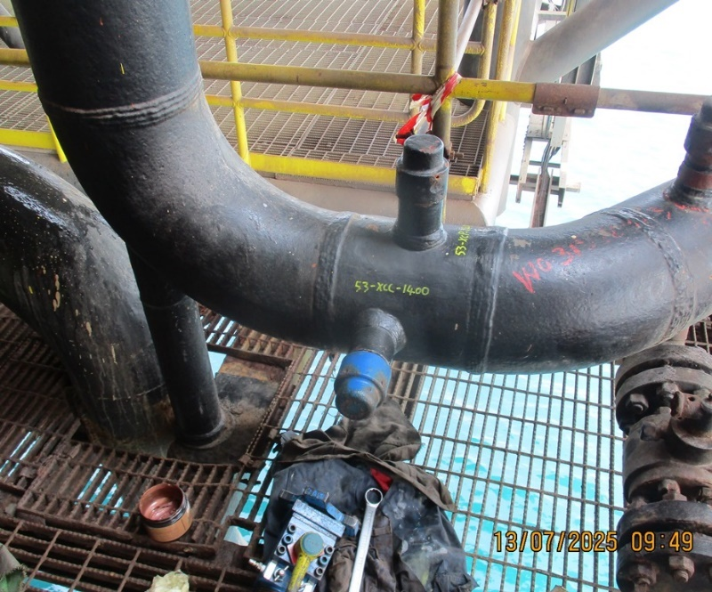 |  |  |  | 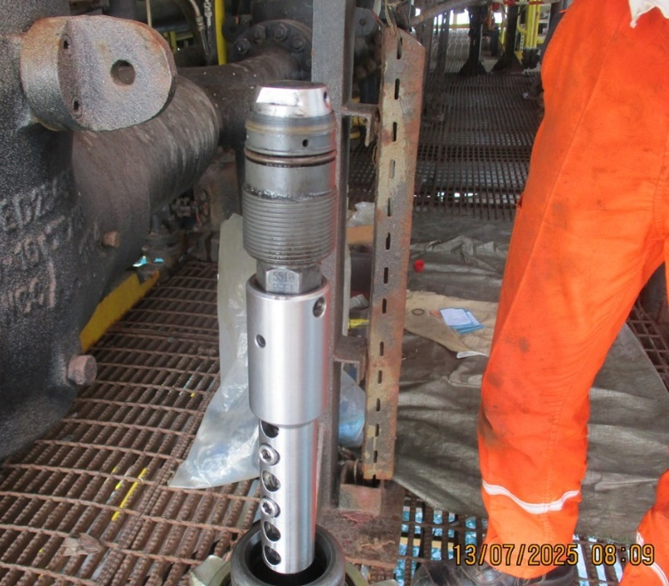 |  |  | 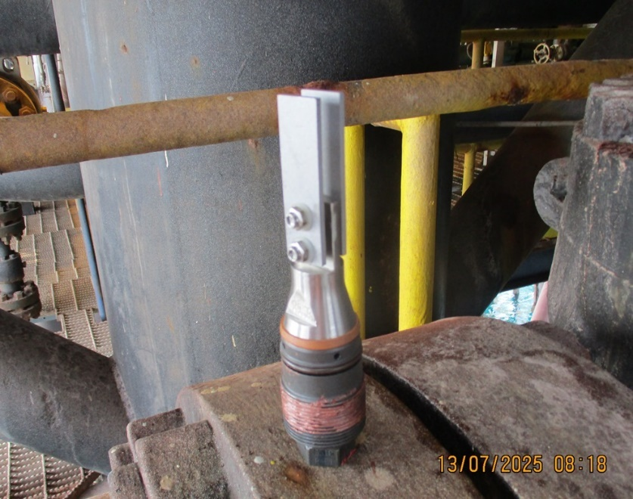
Comments
The Access Fitting at this location appears to be quite new. The old Access Fitting was previously reported as having damaged external threads so had not been serviced for some time. A Solid Plug was retrieved and a new 2.5” Strip Coupon Holder and 3” Strip Coupons Installed. Regular monitoring can now be re-commenced at this location.

Tag No | Line No / Description | Pressure  (psi) | A/F Orientation | Scope of Work | New Probe Size / Specification | Probe Readings | Date | Tool Used | Location Access | Remedial Actions
53-XCP-1401 | 10-OC-530263-15151  10” Oil Line | 1500 | 12 o Clock | Install New ER Probe | 8.75” Flush  4705-S8-K03005-8.75-1 | Check – 802  Div – 53.2  M.Loss – 0.212  CR – N/A | 13-07-2025 | 25” | Access Ok | None Required
Access Fitting Picture |  |  |  | Removed Device |  |  | New Probe
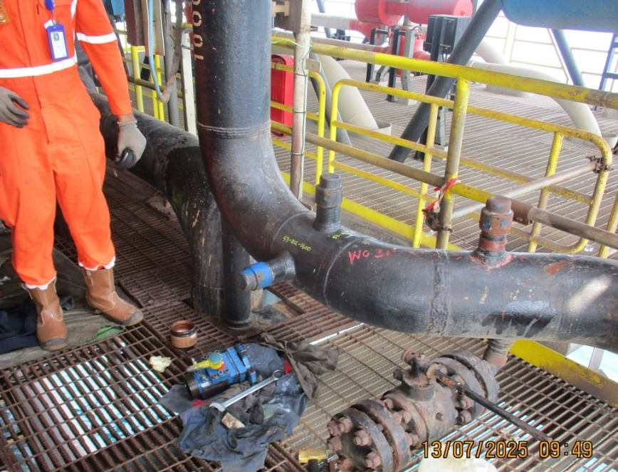 |  |  |  | 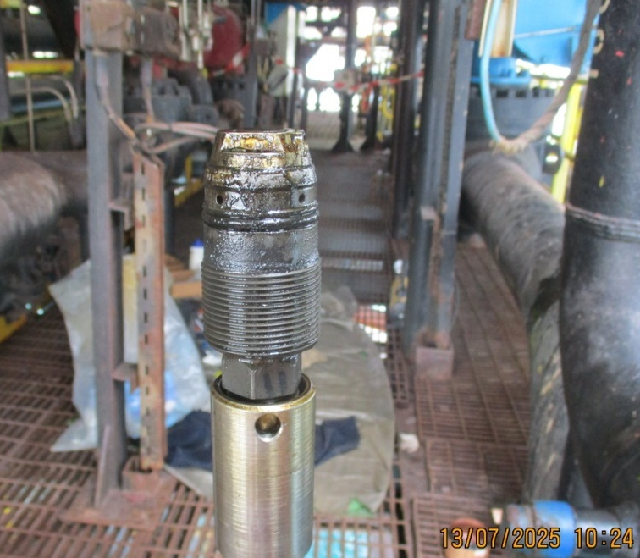 |  |  | 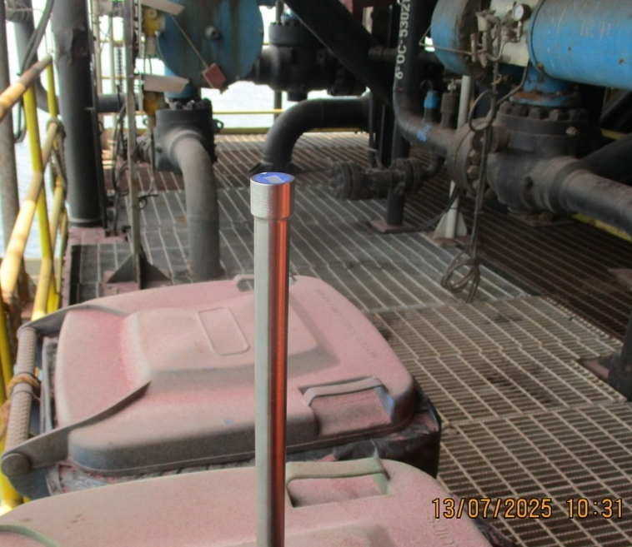
Comments
The Access Fitting at this location appears to be quite new. There does not appear to be any historical information for this location, and it is unknown what the “Official” Tag Number is.. A Solid Plug was retrieved and a new 8.75” S8 Flush ER Probe was installed. A Tag of XCP-1401 was assigned for the purpose of setting up a new ER Probe on the Checkmate Unit. The Probe “ID” on the Checkmate was set at 111, which was the next available memory slot.

Tag No | Line No / Description | Pressure  (psi) | A/F Orientation | Scope of Work | Retrieved Coupons ID /  Holder Length | Coupon Appearance | Installed Coupons ID / Weight / Material / Date | Tool Used | Location Access | Remedial Actions
53-XCC-1143 | 8-OC-530214-15101  8” Oil Line | 200 | 6 o Clock | Remove & Replace Corrosion Coupons | MP999 & MQ000  3.00” Holder | Dark in colour. Minimal corrosion observed | NE586 – 37.0986  NE587 – 36.8974  C1018  13-07-2025 | 18” | Access Ok for tool. | None Required
Access Fitting Photograph |  |  |  | Retrieved Coupons / Device Photograph |  |  | Installed Coupons / Device Photograph
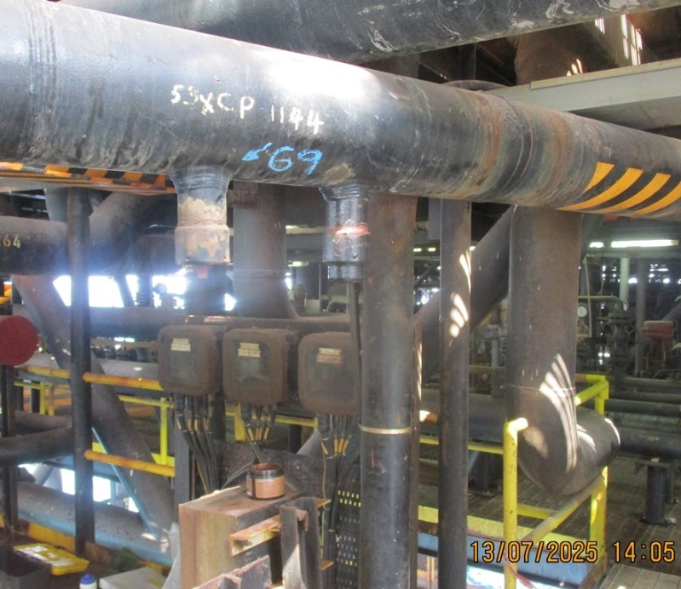 |  |  |  | 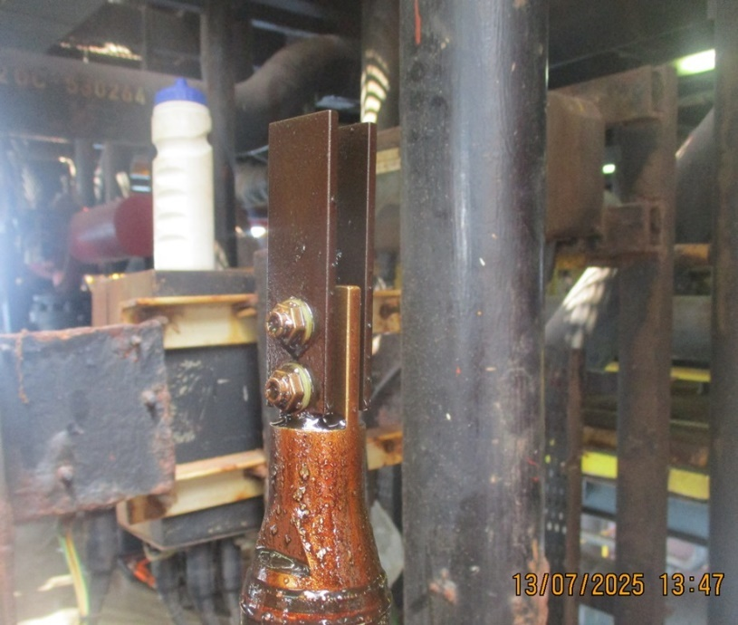 |  |  | 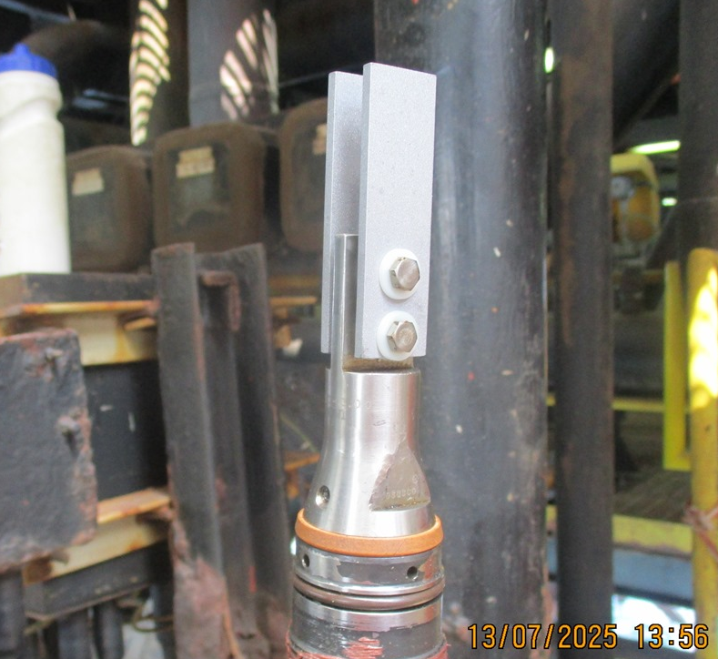
Comments

Tag No | Line No / Description | Pressure  (psi) | A/F Orientation | Scope of Work | Work Performed | Probe Readings | Date | Tool Used | Location Access | Remedial Actions
53-XCP-1144 | 8-OC-530214-15101  8” Oil Line | N/A | 6 o Clock | External Service of Access Fitting | Cap removed, threads brushed and re-greased | Obtained Previously | 13-07-2025 | N/A | Access Ok | None Required
Access Fitting Picture
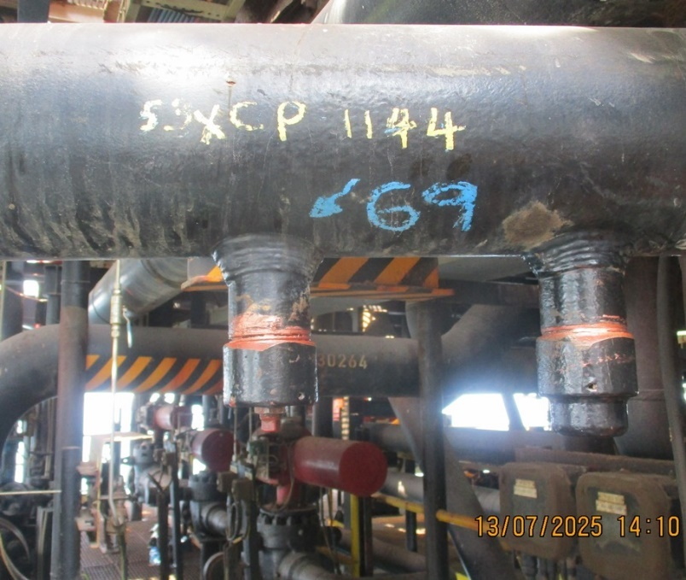
Comments

Tag No | Line No / Description | Pressure  (psi) | A/F Orientation | Scope of Work | Work Performed | Probe Readings | Date | Tool Used | Location Access | Remedial Actions
53-XCC-1402 | 12-OC-530264-15101  12” Oil Bulk Oil Line from BH-D07B WHJ to PS3-C Manifold | N/A | 9 o Clock | External Service of Access Fitting | Cap removed, threads brushed and re-greased. Photo of sealing face obtained | N/A | 13-07-2025 | N/A | Access OK for tool. Scaffold Required | Reface Access Fitting
Access Fitting Picture |  |  |  | Access Fitting Picture
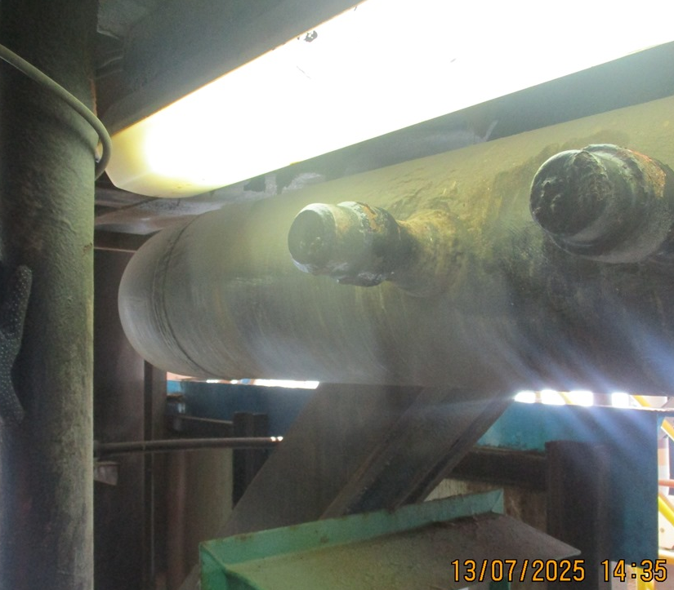 |  |  |  | 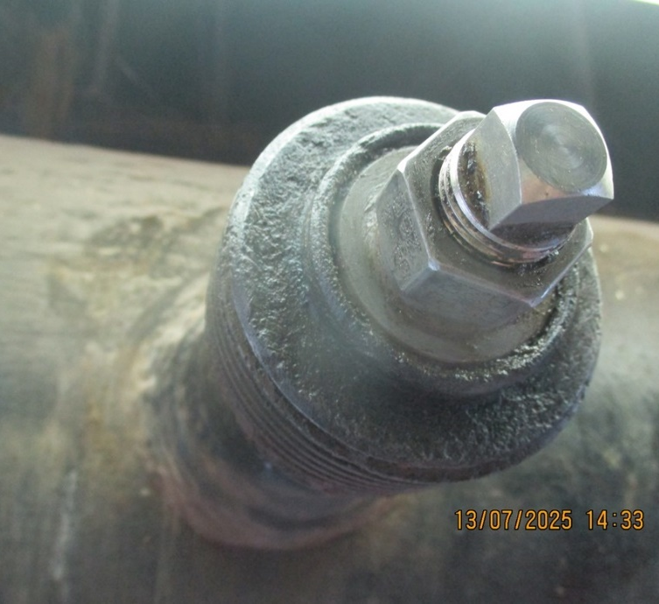
Comments
The external sealing face of this Access Fitting was found to be in very poor condition. Deep pits were identified across the whole surface, which would seriously compromise a safe seal between the Access Fitting and Service Valve during retrieval. It is recommended that the Access Fitting be replaced or the sealing face repaired with a resurfacing tool. The resurfacing tool may be better as the repair can be made while the line is still in service, so no shutdown is required.
This location was also previously reported as having an internal obstruction due to incorrect fabrication. The Access Fitting and the hole in the pipe wall are not correctly aligned so coupons could not be installed.

Tag No | Line No / Description | Pressure  (psi) | A/F Orientation | Scope of Work | Work Performed | Probe Readings | Date | Tool Used | Location Access | Remedial Actions
53-XCP-1403 | 12-OC-530264-15101  12” Oil Bulk Oil Line from BH-D07B WHJ to PS3-C Manifold | N/A | 9 o Clock | External Service of Access Fitting | Cap removed, threads brushed and re-greased | Obtained Previously | 13-07-2025 | N/A | Access Ok. | None Required
Access Fitting Picture
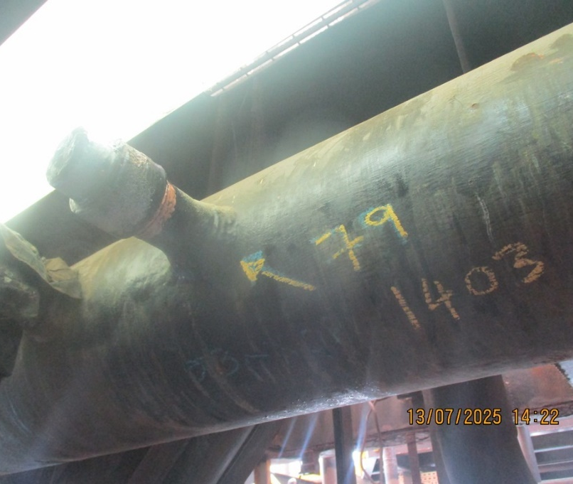
Comments

Tag No | Line No / Description | Pressure  (psi) | A/F Orientation | Scope of Work | Work Performed | Probe Readings | Date | Tool Used | Location Access | Remedial Actions
53-XCC-924 | 10-OC-530016-15151  10” Oil from BH-40-01 WHJ to PS3-C Manifold | N/A | 12 o Clock | External Service of Access Fitting | Cap removed, threads brushed and re-greased. Measurements obtained | N/A | 13-07-2025 | N/A | No Access for Tool | Relocate Access Fitting
Access Fitting Picture |  |  |  | Access Fitting Picture
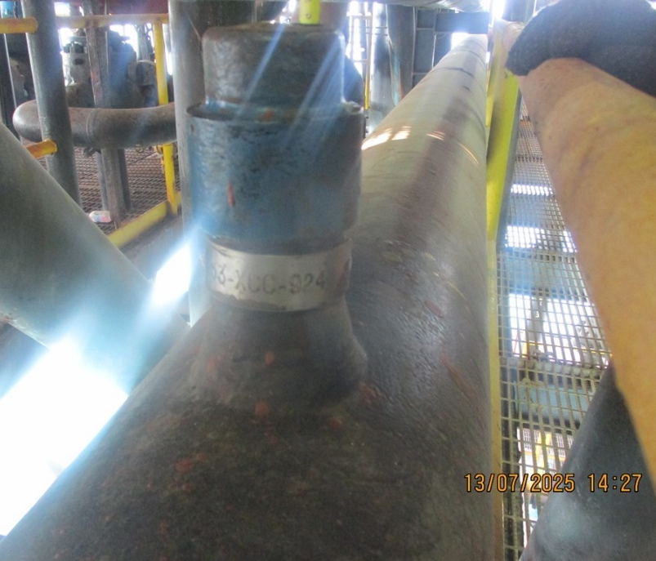 |  |  |  | 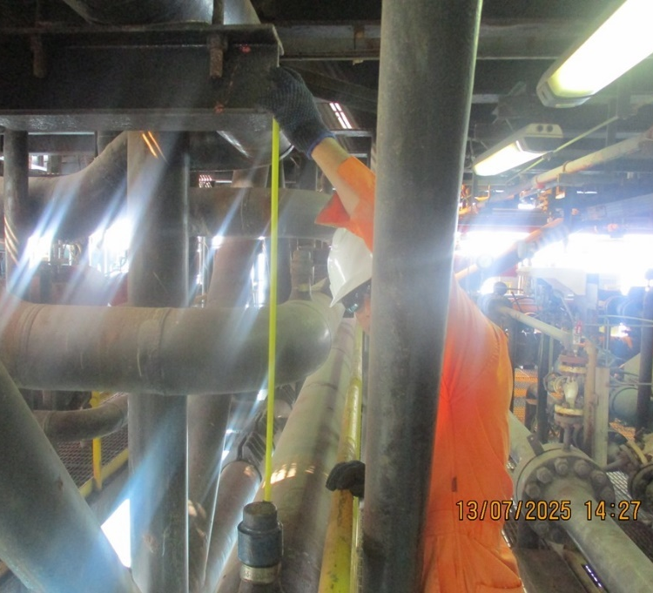
Comments

Tag No | Line No / Description | Pressure  (psi) | A/F Orientation | Scope of Work | Work Performed | Probe Readings | Date | Tool Used | Location Access | Remedial Actions
53-XCC-1142 | 10-OC-530213-15151  10” Line D/S 53XZV-1272 | N/A | 12 o Clock | External Service of Access Fitting | Cap removed, threads brushed and re-greased. Measurements obtained | N/A | 13-07-2025 | N/A | No Access for Tool | An 18” RSL Tool could possibly be used
Access Fitting Picture |  |  |  | Access Fitting Picture
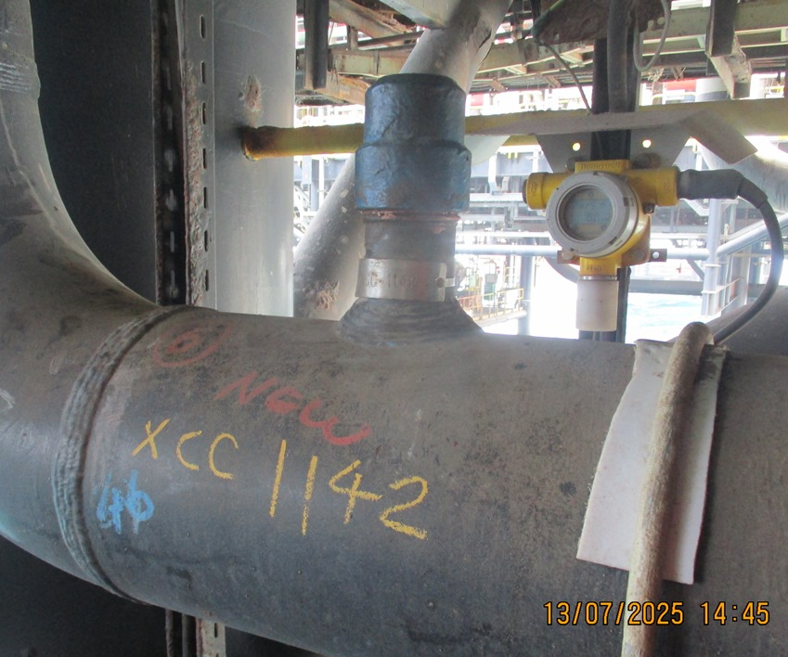 |  |  |  | 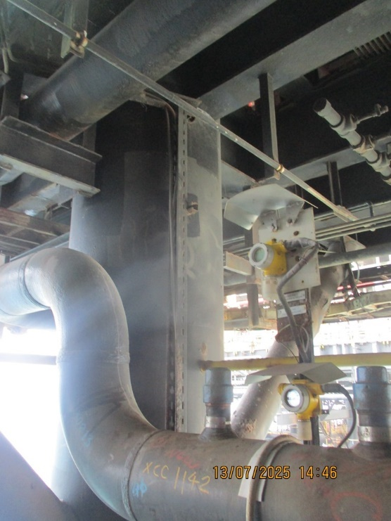
Comments
This location has restricted access for a RBS type tool but can likely be serviced with an 18” RSL non-telescoping tool.

Tag No | Line No / Description | Pressure  (psi) | A/F Orientation | Scope of Work | Work Performed | Probe Readings | Date | Tool Used | Location Access | Remedial Actions
53-XCP-1137 | 10-OC-530213-15151  10” Line D/S 53XZV-1272 | N/A | 12 o Clock | External Service of Access Fitting | External clean of cap only. Measurements obtained for retrieval tool | N/A | 13-07-2025 | N/A | No Access for Tool | Previously reported as leaking, pressure present
Access Fitting Picture |  |  |  | Access Fitting Picture
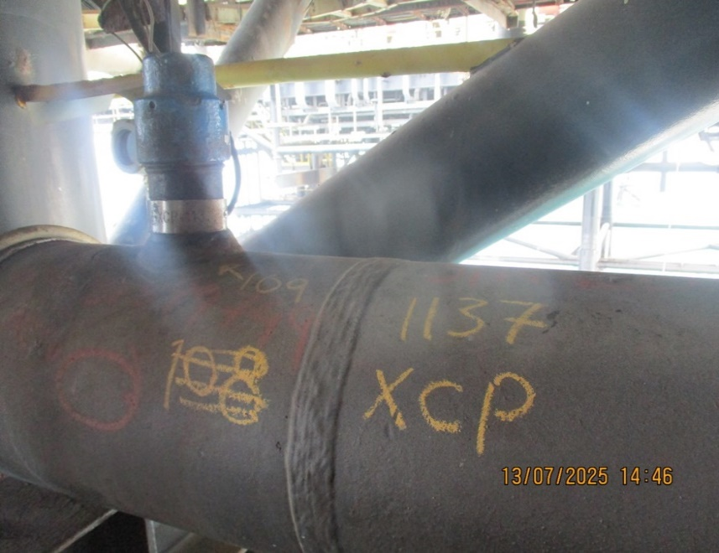 |  |  |  | 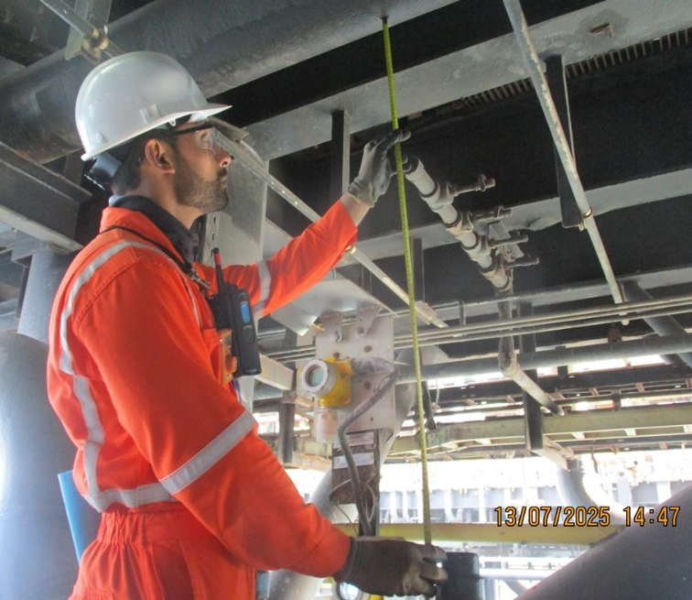
Comments
This location has previously been reported as having a leak, with pressure leaking from the plug. It was decided not to remove the cap until the line can be depressurized and the seals replaced.
This location also has restricted access for a RBS type tool but can likely be serviced with an 18” RSL non-telescoping tool.

Observations & Recommendations

Unfortunately, we could not complete all the retrievals on PS3-C lower deck as the required scaffolding had not yet been completed.

24 Hour Lookahead
The plan for Monday 14th July is to complete the work on PS3-A while we are waiting for scaffolding on PS3-C to be completed

Stuart Dunthorne – Axess-Corrosion. – sdunthorne@axess.energy

